New base/plinth systems for VX and AX enclosures
More room for manoeuvre when routing cables in the base/plinth
Herborn, 2024-09-27.
Speed and simplicity are essential when installing an enclosure. Every minute counts, even when assembling the base or plinth. But even when cables have been introduced, almost everything must still be done in the shortest possible time. Rittal now ensures this with its new base systems for the VX large enclosures and the AX compact enclosures. Control and switchgear manufacturers benefit from a variable modular system for individual and rapid expansion options and high stability and reliability.
Due to their position, enclosure bases are indeed “bearers of responsibility”, both for the enclosure and its interior. However, the most critical issue for plant constructors is simple assembly and a lot of flexibility during expansion. The focus is on comfortable and clean cable entry from below into the interior of the enclosure. That is why Rittal has significantly improved the functionality of its base/plinth system for the VX large enclosure. The new base/plinth is much more than just a stable enclosure base with a protective function: The entire base space beneath the enclosure can be used for flexible cable accommodate, for example, to route them in a structured way via punched sections in the base to the mounting plate or cable clamp rail, or to route them safely from enclosure to enclosure in the bayed suite.
Speed and comfort for assembly
The base/plinth delivery concept saves time and effort because the trim panels are pre-assembled. Practical aids for positioning and fixing, as well as the extensive range of VX accessories for easy cable management and other functions, make every step easy and safe, thus bringing greater speed and convenience to assembly. Thanks to the system punchings on both sides of the corner piece and trim of the VX sheet steel base/plinth, the entire base/plinth space can be used flexibly for individual configurations. Depending on the application's needs, the VX stainless steel base can also be equipped with stainless steel cover caps from the accessories. A structured base extension can also be carried out with rail systems over the corner pieces.

New base/plinth system for AX enclosures
The base/plinth system for the AX is designed for large compact enclosures with depths of 300 mm and 400 mm. Because these enclosures can also be stand-alone, the base can be used for cable routing.
The new AX socket has the advantage over its predecessor, which has been redesigned to offer far more cable space. The base also provides a large variety of options and a simple structure: Thanks to an optimised panel concept, it does not need any corner pieces and uses depth elements as load-bearing components. Interior installation with cable clamp rails or support strips is carried out using the depth elements of the base/plinth. Just as with the VX base/plinth systems, panels between 100 mm and 200 mm high can be selected, and they can also be stacked on top of each other.
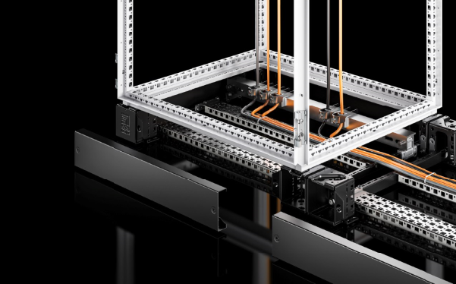 |  | 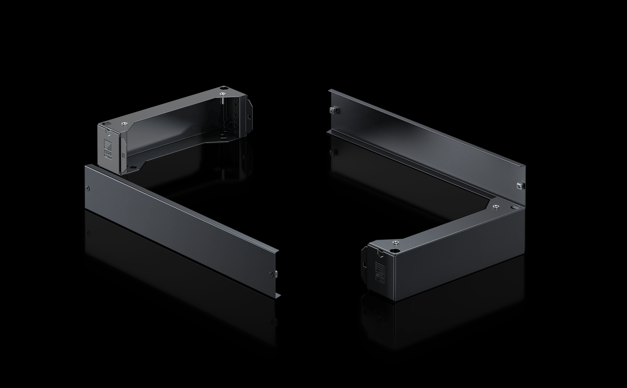
Image 1  New base/plinth for the VX large enclosure: The entire base/plinth space beneath the enclosure can be used to accommodate cables flexibly. |  | Image 2  New base/plinth for the AX compact enclosure: Thanks to an optimised panel concept, it does not need any corner pieces and uses the depth elements as load-bearing components.
May be reproduced free of charge. Please name Rittal GmbH & Co. KG as the source.

Rittal

Rittal is a leading global supplier of enclosure systems, automation and infrastructure with its industrial, IT, energy and power, cooling and service units. Rittal products and solutions are used in over 90% of global industries – standardised, customised, and always of the very best quality.
Our approach and methodology: Rittal, Rittal Software Systems (Eplan, Cideon and German Edge Cloud) and Rittal Automation Systems (RAS, Ehrt, Alfra) combine their hardware and software expertise to streamline, optimise and digitalise processes across the entire value chain for our customers including their IT infrastructure – from control and switchgear construction, machine building to factory operators or the energy sector.
Our delivery promise: Rittal standard products are delivered in Germany within 24 hours, and within 48 hours throughout Europe.
Customer focus
Improving efficiency and increasing productivity through automation and digitalisation is one of the biggest challenges for our customers. This requires in-depth knowledge and expertise, the combination of hardware and software, and cross-sector networking. We are convinced that creating and connecting data rooms is crucial to the success of industrial transformation. And that is exactly our speciality and field of competence.
Eplan and Rittal are driving the development of the digital automation twin, making data accessible and useable in operations as well. Cideon is improving data consistency in the digital product twin context with its CAD/CAM, PDM/PLM and product configuration expertise. German Edge Cloud’s ONCITE Digital Production System (DPS) makes production process data transparent, enabling it to be optimised – right through to energy management using digital production twins.
Sustainability
Environmental and climate protection, social commitment and ethical corporate management are a given for Rittal. We take our responsibility for a sustainable future seriously. Our approach to resource management and conservation involves continuous improvement of our own production processes and ensuring that our products have the lowest possible Product Carbon Footprint. Our solutions support our customers in achieving their own climate targets.
Family business and global player
Founded in 1961, Rittal is the largest company in the owner-operated Friedhelm Loh Group. The group operates worldwide, with more than 12 production sites and over 95 international subsidiaries. It has more than 12,100 employees and posted revenues of 3 billion euros in fiscal 2023. In 2023, the Friedhelm Loh Group was presented with the “Best Place to Learn” and “Employer of the Future” awards. In 2024, Rittal was awarded the Top 100 Seal as one of Germany’s most innovative medium-sized companies for the third time in a row.
For more information, visit www.rittal.com and www.friedhelm-loh-group.com.

Corporate Communications
Dr. Carola Hilbrand Rittal GmbH & Co. KG
Corporate & Brand Communications Auf dem Stützelberg
Tel.: 02772/505-2527 35745 Herborn
hilbrand.c@rittal.de www.rittal.com


Follow us:

